CSA05-DATABASE MANAGEMENT SYSTEMS
LAB OBSERVATION
EXPERIMENT:11
AIM:
To create Auto Increment sequence on the given relation.
QUESTION:
- Populate register number using auto increment in DBMS_Stud table.
SQL QUERIES:
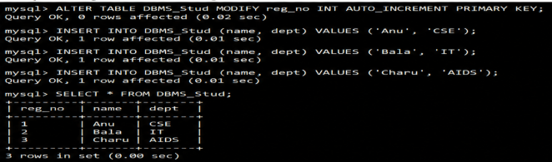
- Manually populate register number
SQL QUERIES:
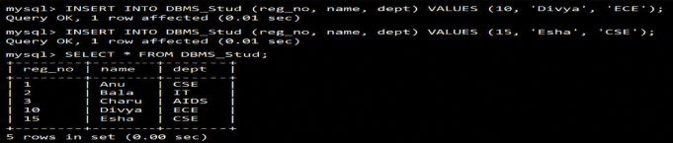
- Drop the auto increment.
SQL QUERIES:
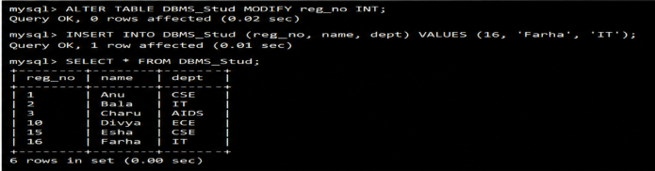
RESULT:
The records from the tables are displayed using auto_incrementsequence on the given relation.

